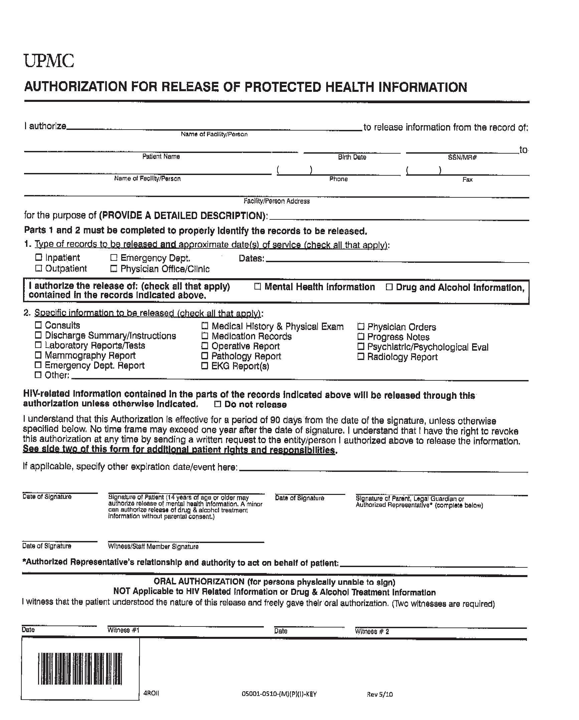
Batman
01/01/1979
xxx-xx-5555
Axiom Requisition Copy Service
(877) 886-5090
(517) 886-4116
2869 Jolly Road, Okemos, MI 48864
FROM 01/01/1979 TO PRESENT: Any and all MEDICAL RECORDS, including but not limited to patient history form(s), reports, etc. pertaining to Batman SSN: xxx-xx-5555, DOB: 01/01/1979.
End of Litigation
University of Michigan Hospital and Health Center

